Grade 7 Accelerated · Unit 3 · Lesson 3  Exponential Expressions  Question Bank - Additional 3.03 | Name______________________  Date______________________  Period____________________

Show your work. Circle your final answer.
1. Two students evaluated 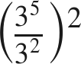. Rylan first wrote 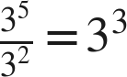, then 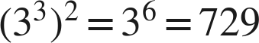. Liam first wrote 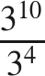, then 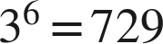.
a. Name the law Rylan used first, and the law he used second.

b. Name the law Liam used first, and the law he used second.

c. List the laws needed to evaluate 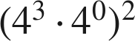, then evaluate it.

For questions 2 through 6, use the laws of exponents to evaluate. Show each law you use.
2. 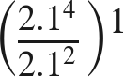

3. 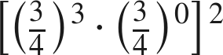

4. 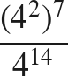

5. 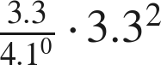

6. 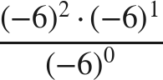

Equivalent or not.
7. Select ALL of the expressions that are equivalent to 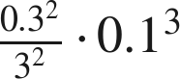.
□ A. 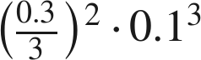
□ B. 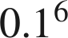
□ C. 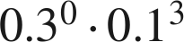
□ D. 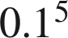
□ E. 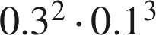
□ F. 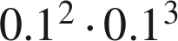

8. Which expression is equivalent to 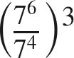 ?
○ A. 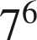
○ B. 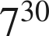
○ C. 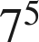
○ D. 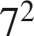

Working backwards.
9. Find the value of that makes each statement true.
a. 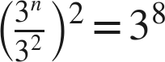

b. 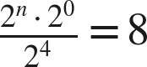

10. Kim says that 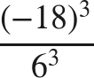 can be rewritten as 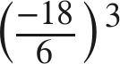 before evaluating. Is she right? Name the law, and give the value.

